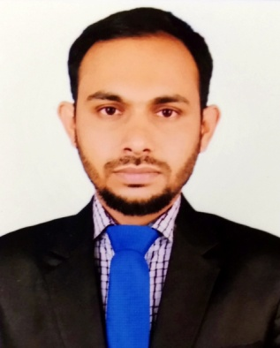Curriculum Vitae

# Abdur Rahman

E-mailaddress : [nijhumrahman588@gmail.com](mailto:nijhumrahman588@gmail.com) Contactno. :+88-01922031588

## *CONTACT INFORMATION*

Abdur Rahman

Noor-A-Alam, Monihar Community Center (5th Floor), Charkamrangi Dhaka 1211.

## *CAREER OBJECTIVE*

To succeed in an environment of growth and excellence and earn a job which provides

me job Satisfaction and self-development and help me achieve personal as well as

organization goals. With a view to develop career so that I can really become a part of the corporate world.

## *EDUCATIONAL INFORMATION*

## *M.S.S ( Political Science)*

## Institute : Govt. Titumir College, (Under Dhaka University)

Passing Year : 2016, Result : 2.97 (Out of 4.00)

## *B.S.S (Political Science)*

Institute : Govt. Titumir College, (Under Dhaka University)

Passing Year : 2015 , Result : CGPA-2.85 (Out of 4.00)

## *H.S.C ( Business Studies)*

Institute : Daulatkhan Abu Abdullah College (Barisal Board)

Passing Year : 2010 , Result : GPA-4.80 (Out of 5.00)

## *S.S.C. (Business Studies)*

Institute : Daulatkhan Govt. Secondary School (Barisal Board)

Passing Year : 2008 , Result : GPA- 4.31 (Out of 5.00)

## *EXPERIENCE*

1. Worked as a Teacher & School management at **Urban Slum Ananda School**, (ROSC Phase-2), 16th June 2015 to 10th October 2019.
2. Worked as a Teacher & School management at **Educo Pathshala Hazaribag,** 13th October 2019 to 29th  February 2020.
3. Work as a Senior Officer at **Runner Automobiles Ltd.** (Sales management, Dealer Point management, Customer Investigation & all kind of activities Runner win software system), 1st March 2020 to 31th January 2021.

## *TARINING*

6 MONTH’S COMPUTER OFFICE MANAGEMENT TARINING**.**

**OfficeManagement:** MS Word, MS Excel, & Internet Browsing.

## *LANGUAGE PROFICIE*

* **Bengali :** Proficient in reading, writing & speaking.
* **English :** Proficient in reading, writing & speaking.

## Expertise

## Customer Service & Satisfaction

## Team Management

## Strong communication, good positive mind and presentation skills

## Profit & loss Calculation

## Analytical Skills, Customer service

## Self- motivated, energetic & dynamic

## SELF ASSESSMENT

* + Able to work with and maintain relations with staff and clients of all levels.
  + Work effectively, independently or as part of a team.
  + Hard working capability.
  + Fast learner.

## *PERSONAL DETAIL*

* 1. Name : Abdur Rahman
  2. Father’s Name : Late. Md. Mozammel Hoque
  3. Mother’s Name : Fozilat Begum
  4. Date of Birth : 25th July,1992
  5. Nationality : Bangladeshi
  6. Religion : Muslim
  7. Sex : Male
  8. Blood Group : O+
  9. Marital Status : Unmarried

## *REFERANCE*

1. **Md. Mizanur Rahman 2.Tizul Islam**

DPE, ROSC Phase-2 Community Participation And Development

Supervisor & Junior Consultant Project Co-ordinator (CPD)

## DPE, Mirpur-2, Dhaka-1216. House No- 1/F, North Adabor,

## Cell: 01721444407   Shamoli, Dhaka-1207.

## [mmrahaman74@gmail.com](mailto:mmrahaman74@gmail.com) Cell: 01714794406

## tizul_1981@yahoo.com

## *DECLARATION*

I do hereby declare and certify that all information stated above in this resume is true and complete to the best of my knowledge.

# 

# ............................

# Abdur Rahman